 | Directions | Visual of Step
1 | Go to https://optimist.tovuti.io/ and click login | 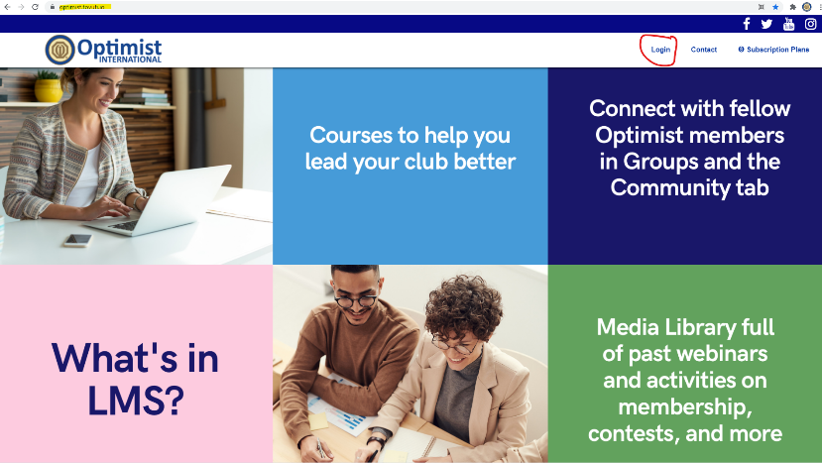
2 | Enter your username and password. If you have forgotten either, email LMS@optimist.org | 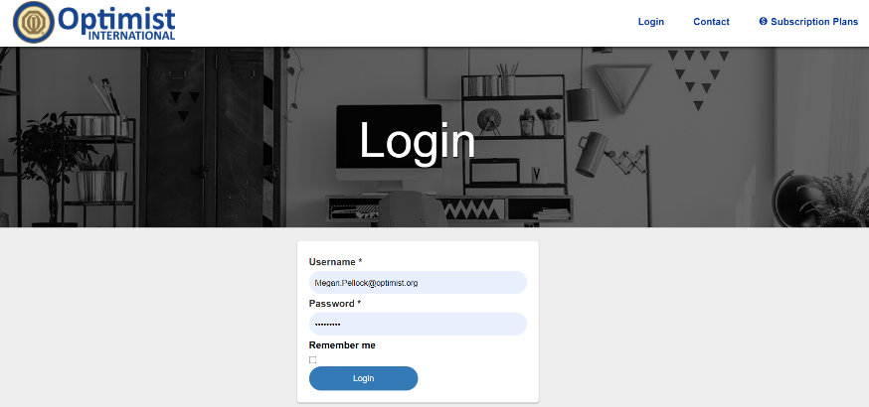
3 | When you first login, you will see the Dashboard. Go to the left-hand side to the blue bar and go to down to “Subscriptions” | 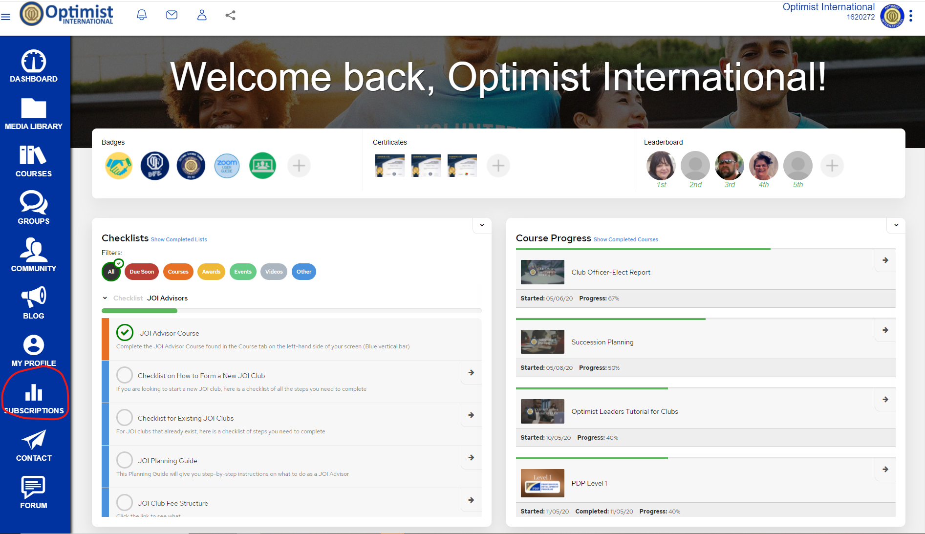
4 | There, you will click on the subscription plan you are trying to switch to (Ex. Member registration to Club President; CFR to CFR elect; Sec-Tres to Pres) | 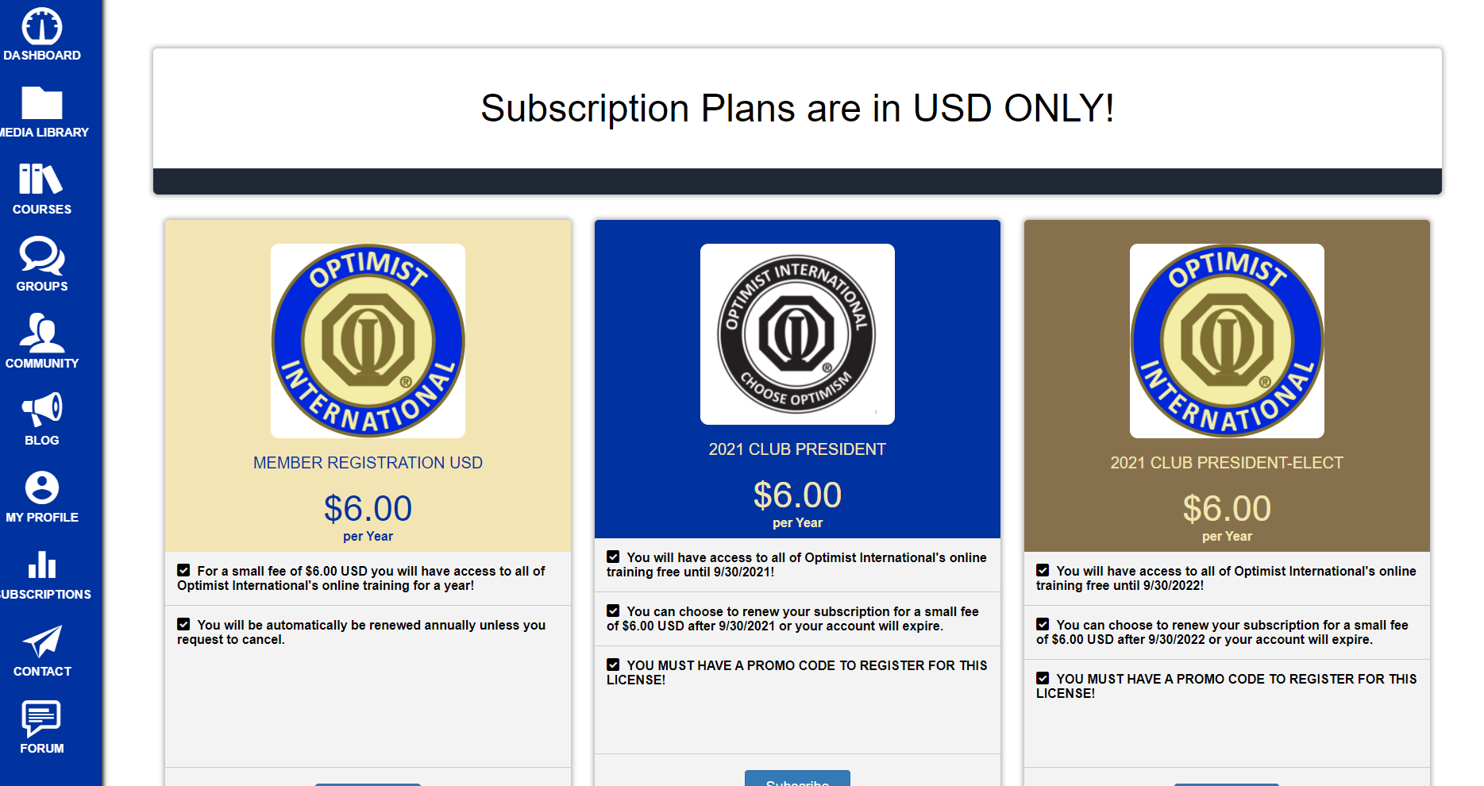
5 | You will be asked to enter your club and member number in the system. When you get to payment information, you will have to enter a promo code (See promo codes below.) if you are a club officer. If you are switching from an officer to a member registration, you will have to enter your credit card information. | 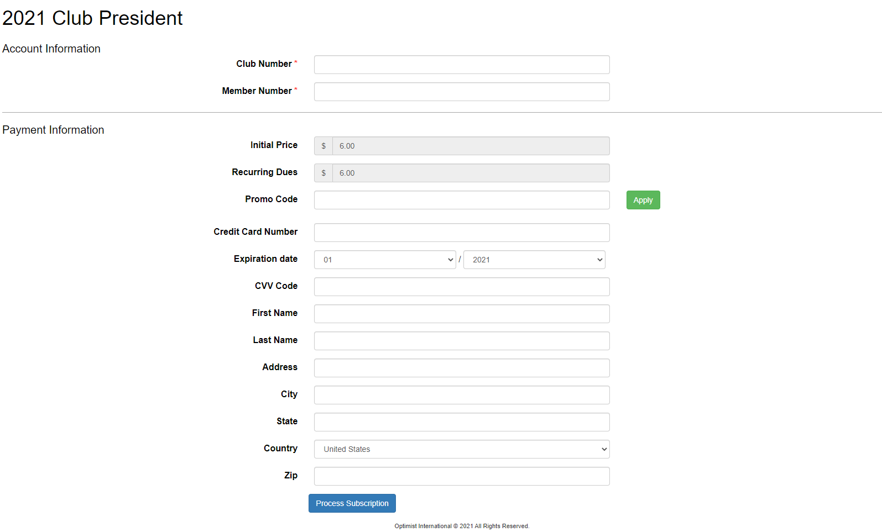
6 | After that, your screen will say that the subscription was successfully processed. You can then go about exploring LMS

